Linux File Permission
Task:
Create a file with .txt extension (/home/demo.txt). Change the permission set of that file, so that any user can read it, group can read/write & owner can read/write/execute it.
Prerequisite:
AWS-Putty.
Step-by-Step Guide:
- Creating a File with Special Permissions
- Create the File
sudo touch /home/demo.txt

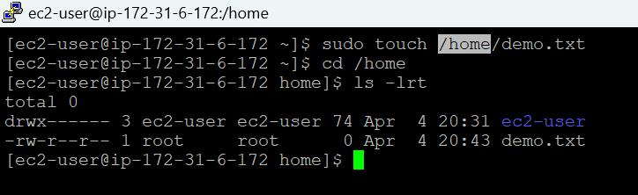

- Set the Right Permissions
- Now we want:
Owner - Read, Write, and Execute
Group - Read and Write
Others (everyone else) - Read only
sudo chmod 764 /home/demo.txt

